Q.1.Create Database.
Ans:
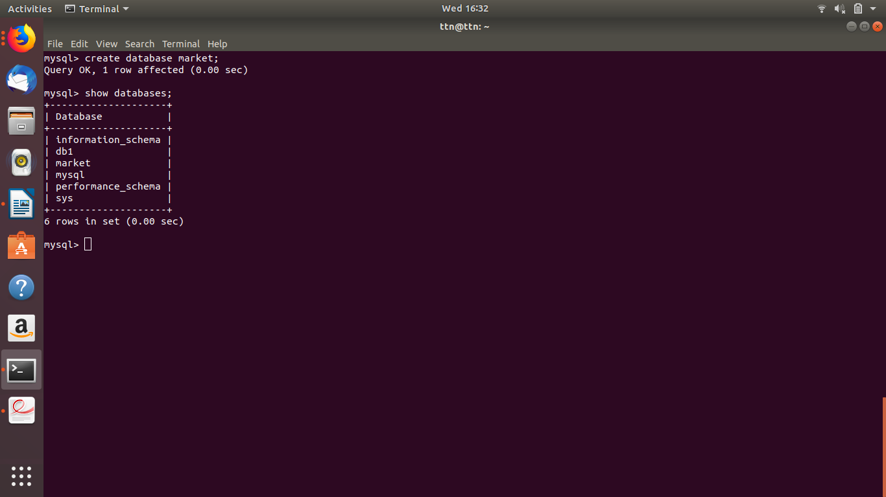

Q.2 Design Schemas.
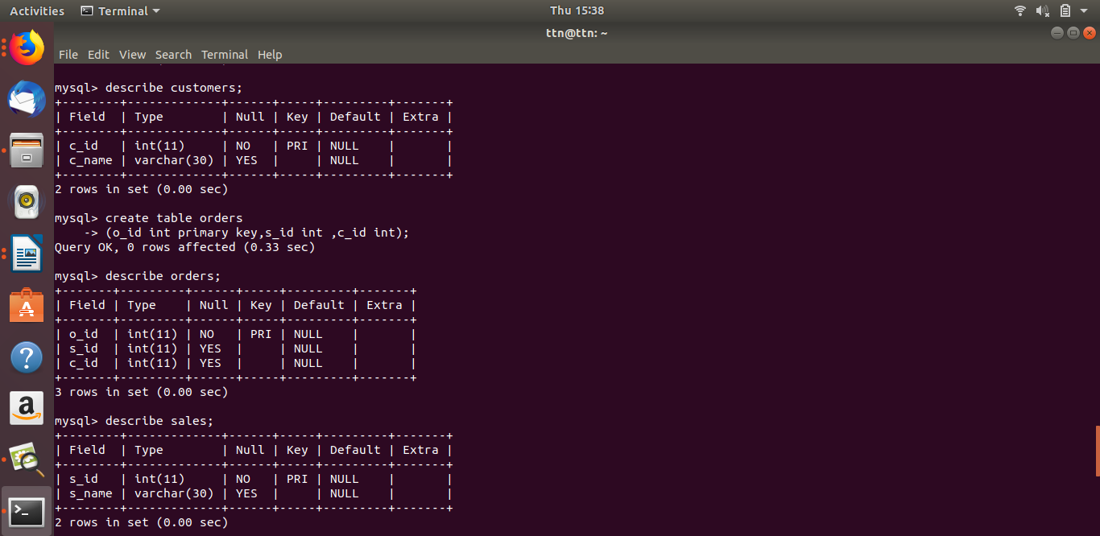
Ans:

Q.3. Create tables .
Ans:
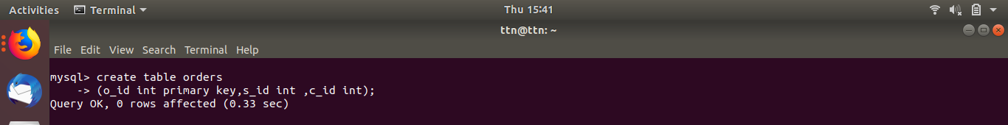
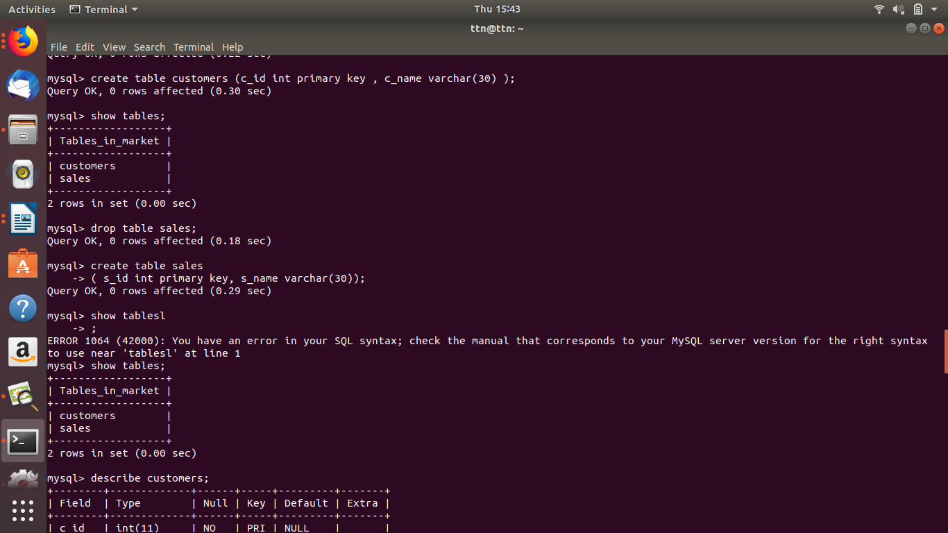

Q.4. Insert sample data .
Ans:

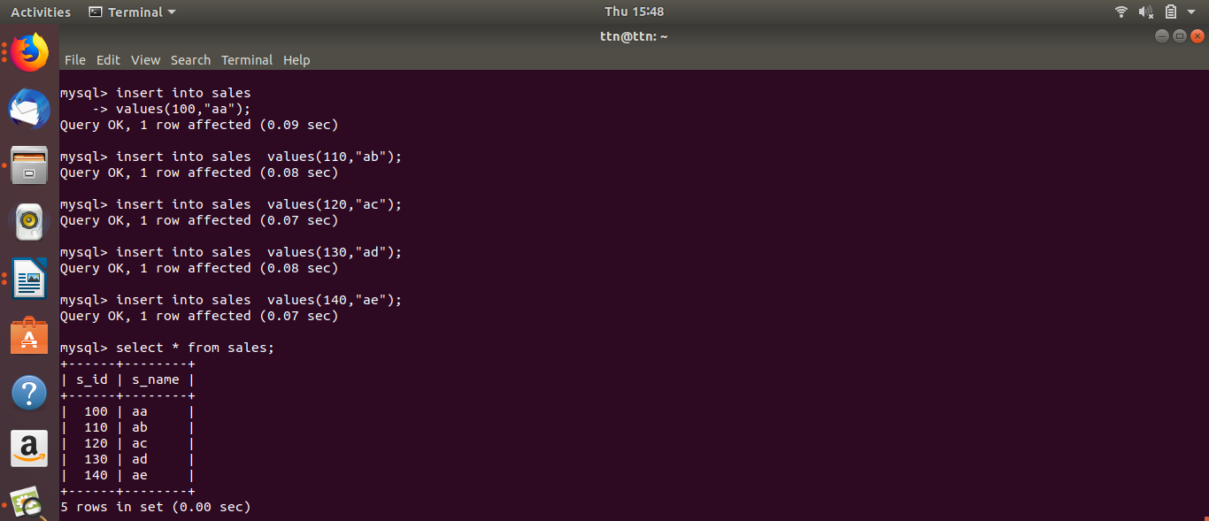
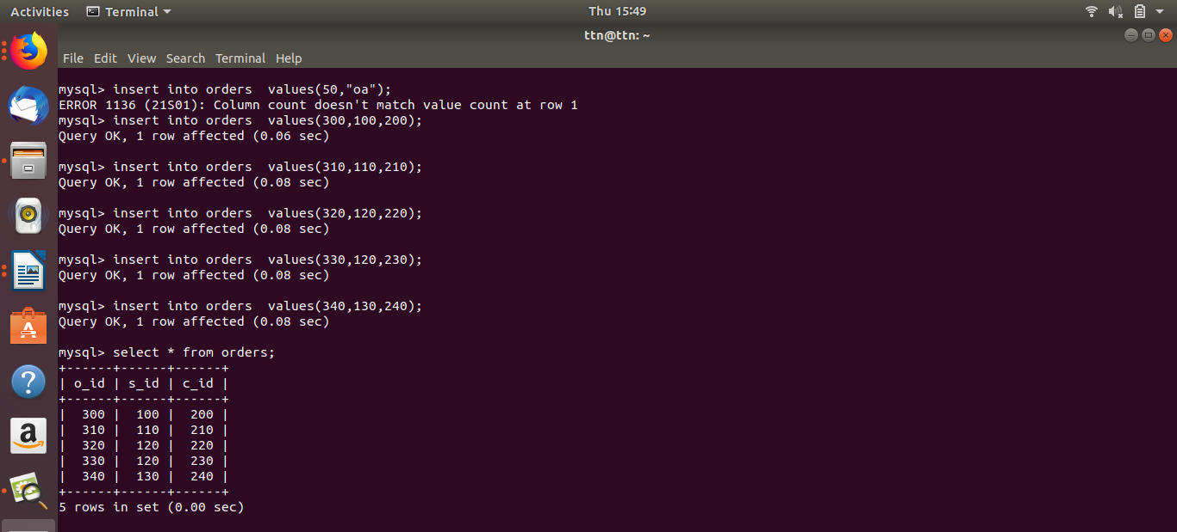
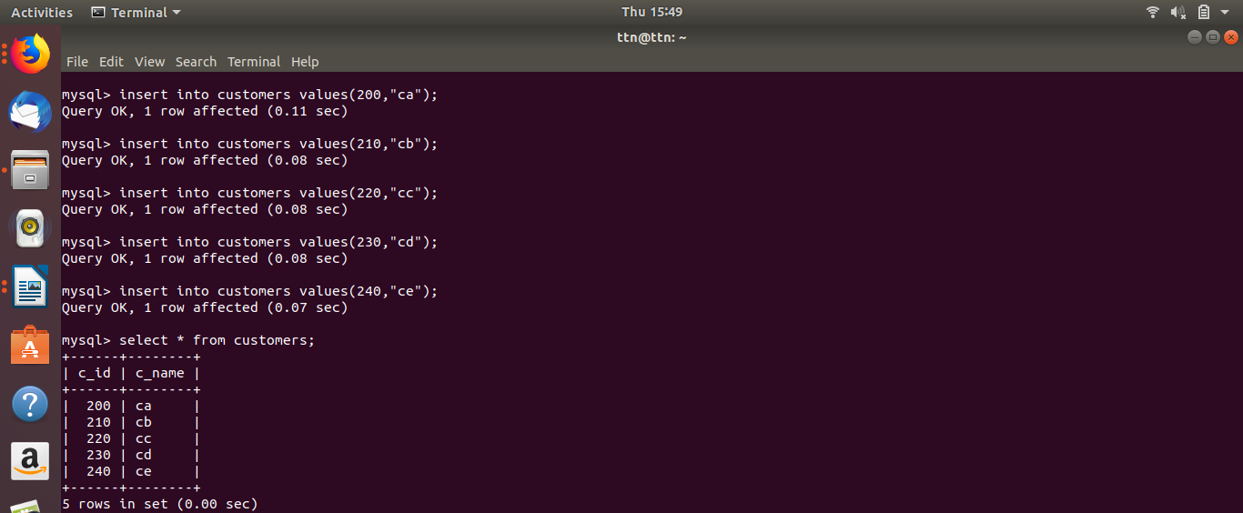

Q.5. Find the sales person have multiple orders.
Ans:

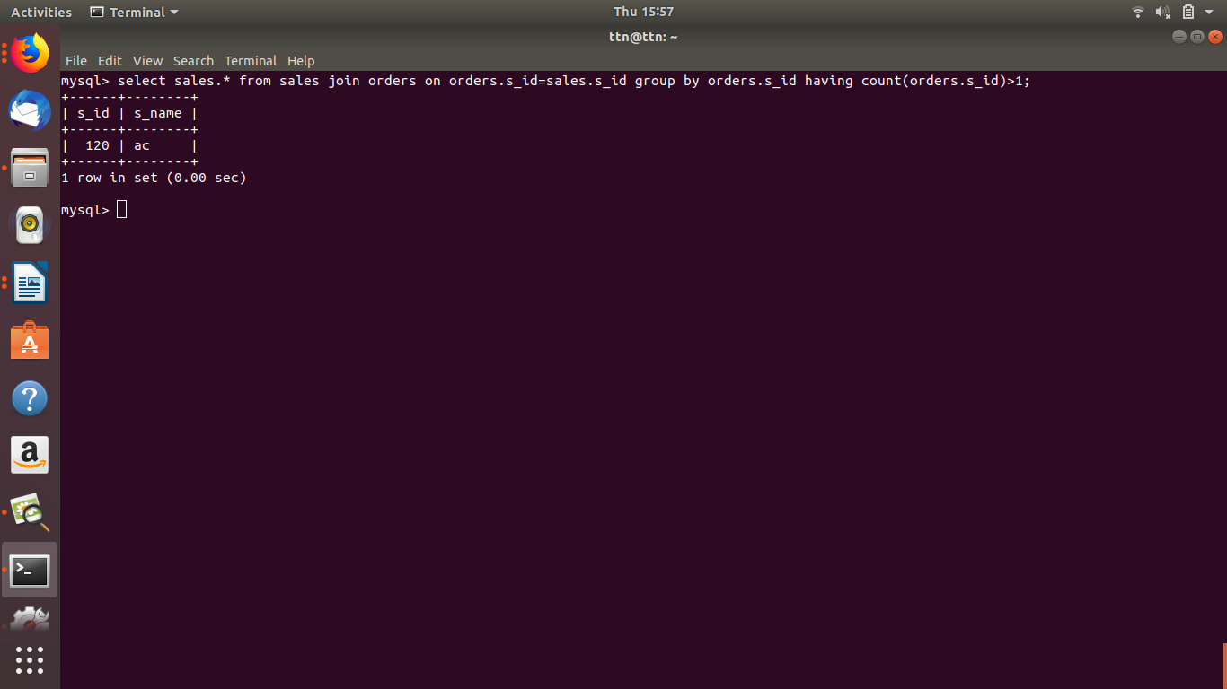

Q.6. Find the all sales person details along with order details
Ans:

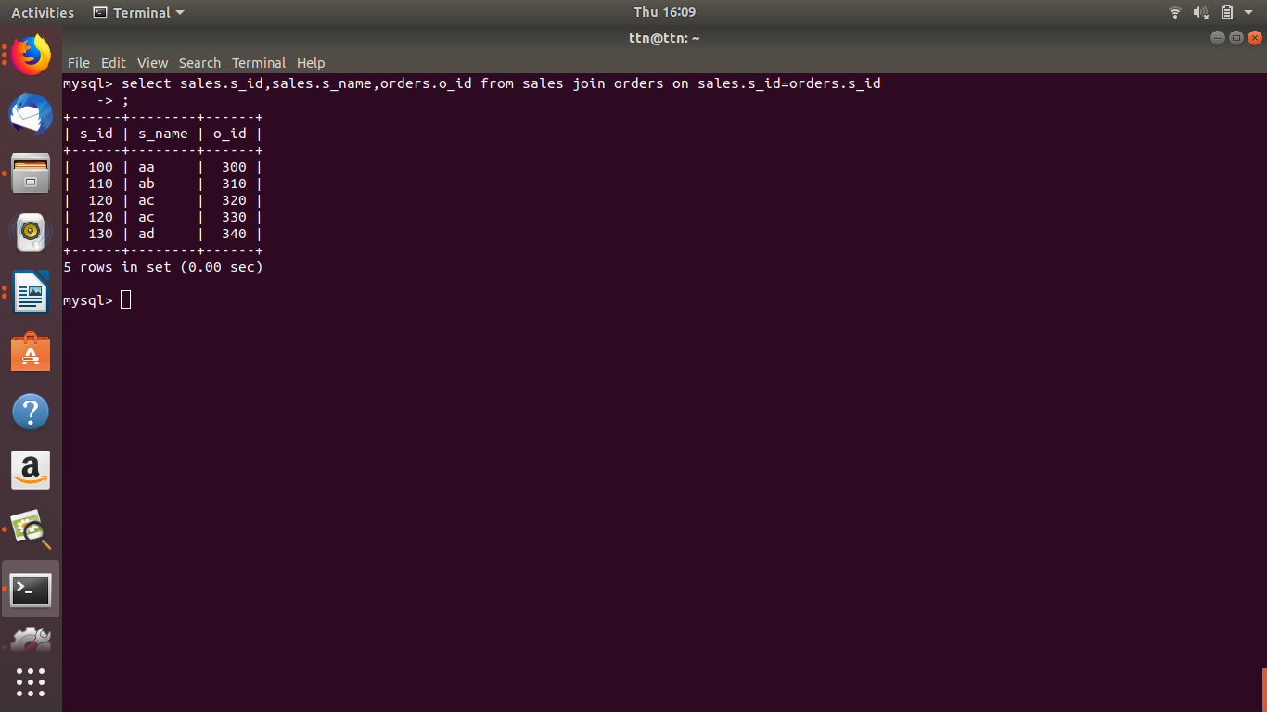

Q.7. Create index
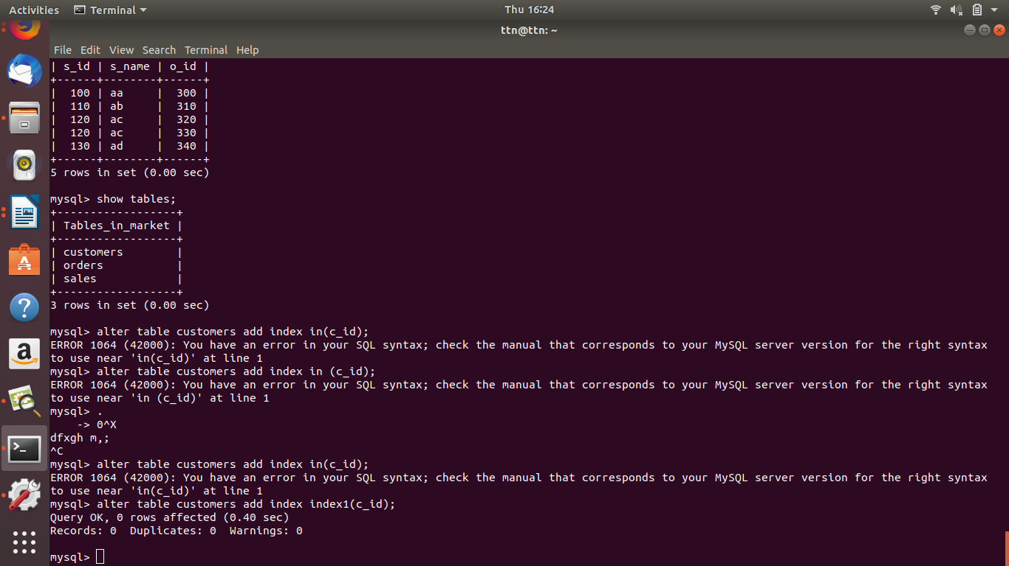
Ans:

Q.8. How to show index on table.
Ans:

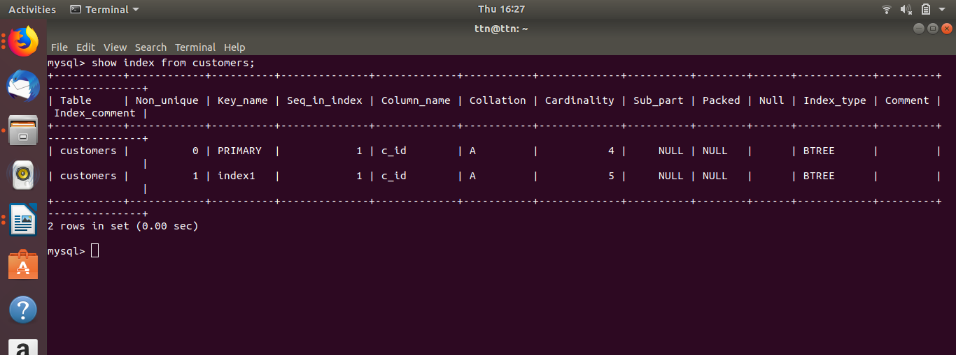

Q.9. Find the order number, sale person name, along with the customer to whom that order belongs to.
Ans:

